Evening bridge lessons
for Beginners

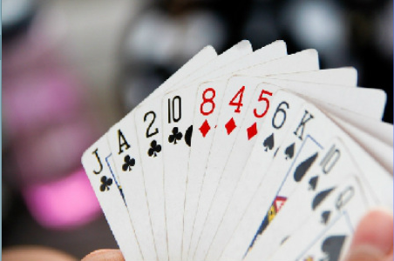 | CORSHAM BRIDGE CLUB  Will be running “Beginner” lessons in Corsham on Tuesday evenings commencing  September 2016.

Playing bridge is good for you – both mentally and socially

COME AND LEARN THE BASICS IN A FRIENDLY LOCAL ENVIRONMENT

No prior knowledge needed. Please register your interest by
e-mailing your details to corshambridgeclub@gmail.com

Or, for further details please telephone:
Sue Phillips 01249 661415 or Chris Baldock 01249 819130
Social bridge players: If you would like to try duplicate bridge at a friendly local club, you’ll find a warm welcome at Corsham Bridge Club. Wednesday evenings 7pm in Royal British Legion clubhouse, Corsham

