CORSHAM BRIDGE CLUB
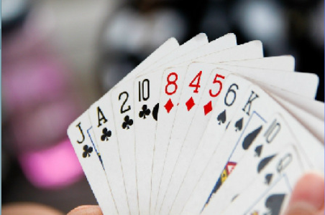 | MEETS WEEKLY IN THE  ROYAL BRITISH LEGION, CORSHAM  WEDNESDAY EVENINGS  AT 7 FOR 7:15  EBU Affiliated
COME AND JOIN US FOR AN EVENING OF FRIENDLY DUPLICATE BRIDGE IN COMFORTABLE SURROUNDINGS
HOT AND COLD DRINKS AND SNACKS AVAILABLE FROM THE BAR
NEW MEMBERS WELCOME
ALL LEVELS OF EXPERIENCE WELCOME
(Novices, please contact us for information on refresher lessons and assisted play sessions)

If you need a partner, please contact:  Ray Elms 01225 810240  or  Sue Phillips 01249 661415 | 